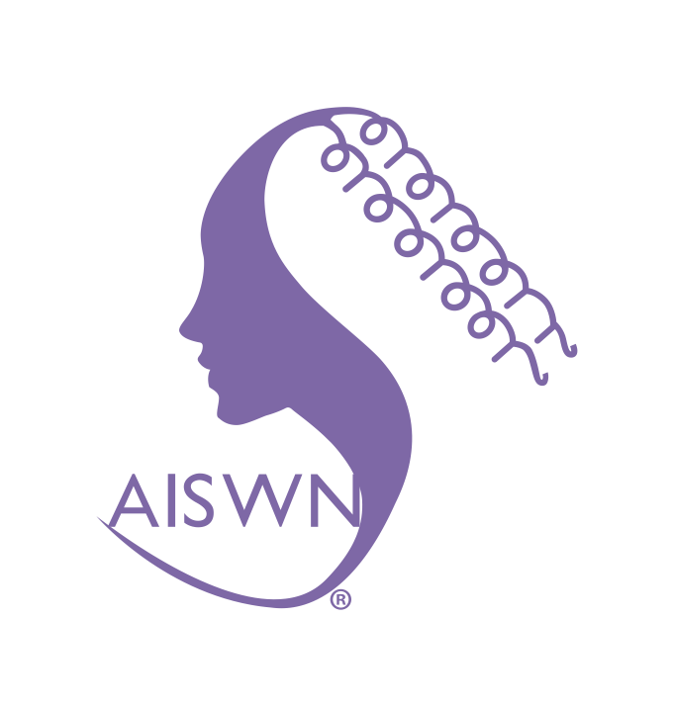

AIS Women’s Network College

2015 Annual Report

http://aiswn.org

As the College was officially established in December of 2014, this document will cover a one year AND one month period

(December 2014 - DECEMBER 2015)

Eleanor Loiacono

AISWN Co-Founding Chair (July 2013-June 2015)

Deb Armstrong

Annemieke Craig

AISWN Co-Chair (July 2015-June 2017)

with the assistance of

AISWN advisors and officers

February 10, 2016

AISWN 2015 Report

(http://aiswn.org)
AISWN is a College affiliated with the Association for Information Systems (AIS). The College was approved by the AIS council in December of 2014 and was the first College of the AIS.

1. MISSION & TOPICS

The AIS Women’s Network is a college of the Association for Information Systems (AIS). The purpose of the College is to promote a network for supporting women scholars in information systems and to enables mentorship relationships that are crucial to speed the success of women in the information systems field.

AISWN’s mission is to:

- Providing a forum for discourse between those interested in furthering the accomplishments, contributions, and careers of women scholars in information systems.
- Providing a forum for a discourse between those in the AIS Women’s Network and members of the broader IS scholarly discipline.
- Facilitating mentorship relationships that support the activities of women scholars in information systems

To fulfill our mission, AISWN is involved in several conferences and workshops. In the one year and one month AISWN has organized events at several conferences and two pre-ICIS workshop on Advancing Women in IS Academia (ICIS 2014 and ICIS 2015).

2. OFFICERS, GOVERNANCE, AND BYLAWS

The officers serving from July 2015 to June 2017 were as follows:

Advisory Board
Cynthea Beath, University of Texas at Austin
Diane Cyr, Simon Fraser University
Jane Fedorowicz, Bentley University
Helmut Krcmar, Technische Universität München
Eleanor Loiacono, Worcester Polytechnic Institute
Diane Strong, Worcester Polytechnic Institute
Jason Thatcher, Clemson University
Cathy Urquhart, Manchester Metropolitan University
Doug Vogel, Harbin Institute of Technology

Founding Co-Chairs
Eleanor Loiacono, Worcester Polytechnic Institute
Cathy Urquhart, Manchester Metropolitan University

Current Chair
Deb Armstrong, Florida State University
Annemieke Craig, Deakin University

Future Co-Chairs
Not applicable yet.

Immediate Past Co-Chairs
Eleanor Loiacono, Worcester Polytechnic Institute
Cathy Urquhart, Manchester Metropolitan University

Treasurer/Funding Chair
Lakshmi Iyer, University of North Carolina at Greensboro

Ph.D. Representative
Camille Grange, HEC Montréal

Newsletter Editor
Upasna Bhandari, National University of Singapore

ACIS Networking Event Chair
Annemieke Craig, Deakin University

AMCIS Networking Event Chair
Lakshmi Iyer, University of North Carolina at Greensboro
Eleanor Loiacono, Worcester Polytechnic Institute

ECIS Networking Event Chair
Elena Gorbacheva, University of Munster

HICSS Networking Event Chair
Cindy Riemenschneider, Baylor University

ICIS Networking Event Chair
Deb Armstrong, Florida State University
Annemieke Craig, Deakin University

PACIS Networking Event Chair
TBD, TBD

Webmaster/Social Media/Listserv Manager
Eleanor Loiacono, Worcester Polytechnic Institute

3. ACTIVITIES & ACCOMPLISHMENTS

AISWN has received a high level of interest and support from enthusiastic members at all levels within academia, including Ph.D. students, untenured faculty members, mid-career faculty, and senior scholars. With the hard work of the organizing team, AISWN continues to support its members in multiple ways. In this limited space, we report the activities and accomplishments over the past one-year and one-month (December 2014 to December 2015).

3.1. Identity and Community Building

In keeping with its mission, AISWN continues to advance the goal of promote a network for supporting women scholars in information systems and to enable mentorship relationships that are crucial to speed the success of women in the information systems field. Our membership roster has over 300 members, though not all are AIS members. Since we have just been established as a college, we have had none AIS members join our social media sites. The AISWN will be working with AIS on integrating membership and setting up the website connections to AIS. AISWN members represent academic (faculty and doctoral students) and a variety of industry and service sectors. The membership has a global impact representing over 30 countries and six continents. We have both a LinkedIn (344 members) and Facebook (73 members) presence since 2011. We have a discussion listserv on AIS groups with 172 members currently.

3.2. Communications and Outreach

In the past year, we have continued to promote the awareness of AISWN. Now that we have been established as the first AIS College, we are stepping up our interaction with the AIS community and building broader representation in the community in hopes of promoting greater participation and dialog with members and other groups, such as SIGs and Colleges. These activities were carried out using four levels of communications: College-wide communication, promotion of AISWN in the MIS community, dialog with other Women associations, and connections with industry, such as IBM.

3.3. AISWN Sponsored Workshops, Conferences, & Meetings

AISWN has established, sponsored, and organized the annual, Pre-ICIS Workshop on Advancing Women in IS. AISWN also participates in the following conferences: AMCIS (Americas Conference on Information Systems), ECIS (European Conference on Information Systems), HICSS (Hawaiian International Conference on System Sciences), ACIS (Australasian Conference on Information Systems) and other conferences attended by its members.

Table 1 summarizes these conferences/meetings.
Table 1. Summary of Meetings

Executive Meetings
Date: | January 19, 2015
Duration: | One hour
Annual General Meeting
Date: | December 14, 2015
Duration: | Two hours
ACIS 2014 Women’s Networking Event, Auckland, New Zealand
Date: | December 8, 2014
Format: | Reception (2 hours)
Chairs: | Annemieke Craig
Participants: | 88
Guest Speakers: | Liz Gosling (CIO Auckland University of Technology NZ)  Phirley Gregor (Australian national University, Australia)
Pre-ICIS 2014, Auckland, New Zealand*
Date: | December 13, 2014
Format: | Workshop (1 day)
Chairs: | Eleanor Loiacono, &  Lakshmi Iyer
Research Panelists: | Deb Armstrong, (Florida State University, USA),  Jenine Beekhuyzen, (Griffith University, Australia), Annemieke Craig (Deakin University, Australia)
Editor Panelists: | Paul Goes, (Editor of MISQ), Richard Baskerville, (Editor of EJIS),  Chris Sauer, (Editor of ISJ),  Roger Debreceny (Editor of JIS)
Participants: | 27
Stipends: | 9
Special Events: | Networking breakfast & lunch, research & editorial panels.
ICIS 2014 Women’s Networking Event, Auckland, New Zealand
Date: | December 15, 2014
Format: | Reception (2 hours)
Chairs: | Deb Armstrong &  Annemieke Craig
Participants: | 96
Guest Speakers: | Iris Junglas (Florida State University, USA)  Yeliz Eseryel (University of Groningen, NL), &  Marta Indulska (University of Queensland, Australia)

HICSS 2015 Kauai, Hawaii
Unaffiliated Women’s Social.
AMCIS 2015 Networking Event, Puerto Rico
Date: | August 13, 2015
Format: | Reception (1 hour.5 hours)
Chairs: | Lakshmi Iyer and &  Eleanor Loiacono
Participants: | 75
Guest Speakers: | Networking event with updates from co-chairs.
ECIS 2015, IS Women's Networking Event,
Münster, Germany
Date: | May 27, 2015
Format: | Reception (1.5 hours)
Chairs: | Elena Gorbacheva
Participants: | 65
Guest Speakers: | Jenine Beekhuyzen (Griffith University, Australia)
ACIS 2015 Women’s Networking Event, Adelaide, Australia
Date: |  | December 2, 2015
Format: |  | Reception (2.5 hours)
Chairs: |  | Annemieke Craig
Participants: |  | 113
Guest Speakers: |  | Caroline Chan (RMIT University, Australia)  John Lamp, (Deakin University, Australia)
Pre-ICIS 2015, Fort Worth, Texas*
Date: | December 12, 2015
Format: | Workshop (1 day)
Chairs: | Eleanor Loiacono &  Lakshmi Iyer
Participants: | 45
Stipends: | 6
Panelists | Manju Ahuja (University of Louisville, USA),  Claudia Loebbecke (University of Cologne, Germany)  Carol Saunders (University of Central Florida, USA)
Breakout Session Leaders: | Upasna Bhandani (National University of Singapore)  Camille Grange (HEC Montréal)  Sandra Richardson (University of Memphis)
Guest Speaker: | Elizabeth Suarez, Professional Negotiator

ICIS 2015 Women’s Networking Event, Fort Worth, Texas
Date: | December 15, 2015
Format: | Reception (2 hours)
Chairs: | Deb Armstrong &  Annemieke Craig
Participants: | 122
Guest speakers: | Olivera Marjanovic (University of Sydney, Australia)  Dubravka Cecez - Kecmanovic (UNSW, Australia)  Romelia Flores, (IBM)
* Sponsored by Elsevier Foundation.
Note: All activities are open to AIS members.

3.4. Special Issues of Refereed Academic Journals

We have not yet established or sponsored any special issues related to women or gender studies within IS, but hope to do so in the future. Research has been undertaken through an Elsevier Foundation sponsored survey (2014-2015). A paper reporting on this work and the efforts to support female academics in the discipline of Information Systems (IS) over recent years is forthcoming in CAIS. A previous paper was also published in CAIS reporting on the 2013 ICIS Women’s Breakfast Panel, which discussed the need to continue the ICIS Women’s Breakfast in some form. Future research to gain an understanding of the low numbers of women in IT academic roles is underway as well.

3.5. AISWN Annual Election

In May 2015, Eleanor Loiacono administered the annual election for the position of SIG Co-Chair-Elects. Annemieke Craig and Deb Armstrong were nominated, and the election was completed on June 12, 2015. Annemieke Craig and Deb Armstrong were elected as Co-Chair, effective July 1, 2015.

3.6. Awards

Service awards were presented to those helping with the Pre-ICIS 2015 Workshop. They include: Manju Ahuja, Claudia Loebbecke, Carol Saunders, Upsana Bhandani, Camille Grange, and Sandra Richardson.

4. SERVICES TO MEMBERS & COMMUNITIES

AISWN provides a range of services to its members (see AISWN website, http://aiswn.org, for these services). The AISWN website has information about every aspect of AISWN, including the mission, bylaws, membership, listserv, conferences, newsletters, photo gallery, and AISWN officers and contact information.

5. FINANCIAL MATTERS

AIS maintains the accounting records for AISWN. Currently, we have approximately $200, but are working to obtain more funding. Eleanor Loiacono obtained a two-year, $67,000 grant from the Elsevier Foundation, and along with Lakshmi Iyer, they developed and delivered the 2014 and 2015 Pre-ICIS Workshop on Advancing Women in IS Academia held in Auckland, New Zealand in 2014 and Fort Worth, Texas in 2015. Companies and universities have been very supportive of AISWN. The ICIS 2014 Women’s Networking Event was sponsored by Florida State University. The AMCIS 2015 social event was sponsored by AIS, Worcester Polytechnic Institute, and the University of North Carolina at Greensboro. The ICIS 2015 Women’s Networking Event was sponsored by the IBM Academic Initiative and Florida State University.

Minimal dues of $10 have been established.

6. LOOKING FORWARD
It has only been one year and one month since the establishment of AISWN and we have been busy establishing processes and growing awareness of the group. We would like to thank everyone who has contributed to AISWN in various ways, including those on AIS Council for their support. AISWN has made significant progress through the support of its advisors, sponsor, officers, and members, who continue to lend their creative and diligent efforts to make AISWN a success.

Given the strong efforts of all involved, AISWN continues to evolve and grow to meet the needs of its members. I am confident that under the leadership of Deb Armstrong and Annemieke Craig, AISWN will continue to flourish and provide even better services to its members.

Loiacono, E., Iyer, L. Armstrong, D., Beekhuyzen, J., and Craig, A. “AIS Women’s Network: Advancing Women in IS Academia” Communications of the AIS, forthcoming.
Loiacono, E., Urquhart, C., Beath, C., Craig, A., Thatcher, J., Vogel, D., and Zigurs, I. “Thirty Years and Counting: Do We Still Need the ICIS Women’s Breakfast?” Communications of the AIS, 2013, Volume 33, Article 6, pp. 81-96.

